Adrian Atkinson

(2014)

“Urban environment
in the context of development:
the case of Southeast Asia.”



Un document produit en version numérique par Jean-Marie Tremblay, bénévole,
professeur de sociologie au Cégep de Chicoutimi
Courriel: jean-marie_tremblay@uqac.ca
Site web pédagogique : http://www.uqac.ca/jmt-sociologue/

Dans le cadre de: "Les classiques des sciences sociales"
Une bibliothèque numérique fondée et dirigée par Jean-Marie Tremblay,
professeur de sociologie au Cégep de Chicoutimi
Site web: http://classiques.uqac.ca/

Une collection développée en collaboration avec la Bibliothèque
Paul-Émile-Boulet de l'Université du Québec à Chicoutimi
Site web: http://bibliotheque.uqac.ca/

Politique d'utilisation
de la bibliothèque des Classiques

Toute reproduction et rediffusion de nos fichiers est interdite, même avec la mention de leur provenance, sans l’autorisation formelle, écrite, du fondateur des Classiques des sciences sociales, Jean-Marie Tremblay, sociologue.

Les fichiers des Classiques des sciences sociales ne peuvent sans autorisation formelle:

- être hébergés (en fichier ou page web, en totalité ou en partie) sur un serveur autre que celui des Classiques.
- servir de base de travail à un autre fichier modifié ensuite par tout autre moyen (couleur, police, mise en page, extraits, support, etc...),

Les fichiers (.html, .doc, .pdf, .rtf, .jpg, .gif) disponibles sur le site Les Classiques des sciences sociales sont la propriété des Classiques des sciences sociales, un organisme à but non lucratif composé exclusivement de bénévoles.

Ils sont disponibles pour une utilisation intellectuelle et personnelle et, en aucun cas, commerciale. Toute utilisation à des fins commerciales des fichiers sur ce site est strictement interdite et toute rediffusion est également strictement interdite.

L'accès à notre travail est libre et gratuit à tous les utilisateurs. C'est notre mission.

Jean-Marie Tremblay, sociologue
Fondateur et Président-directeur général,
LES CLASSIQUES DES SCIENCES SOCIALES.
Cette édition électronique a été réalisée par Jean-Marie Tremblay, bénévole, professeur de sociologie au Cégep de Chicoutimi à partir de :

Adrian Atkinson

“Urban environment in the context of development: the case of Southeast Asia.”

In Françoise Lieberherr-Gardiol and Germán Solinís (editors), CITIES INTO THE FUTURE. Chapter 6, pp. 210-247. A Book translated from the French version Quelles villes pour le 21e siècle ? published with the support of l’Université de Genève, la Faculté des Lettres, La Maison de l’histoire and La Fondation Hélène et Victor Barbour by Les Éditions Infolio, Suisse, 2012, 448 pp. Chicoutimi: Les Classiques des sciences sociales for the English Version, 2014, 323 pp.

[Autorisation formelle accordée conjointement par l’auteur ainsi que par Françoise Lieberherr-Gardiol et German Solinis, d'une part, et par la maison d'édition, infolio Éditeur, d'autre part, le 11 février 2014 de diffuser la version anglaise de ce livre en accès ouvert et gratuit à tous dans Les Classiques des sciences sociales.]

Emails: Françoise Lieberherr-Gardiol: franlieb@bluewin.ch
Germán Solinís: G.Solinis@unesco.org
Adrian Athinson: atkinson@newsynergies.ch

Polices de caractères utilisée :

Pour le texte: Times New Roman, 14 points.
Pour les notes de bas de page : Times New Roman, 12 points.

Édition électronique réalisée avec le traitement de textes Microsoft Word 2008 pour Macintosh.

Mise en page sur papier format : LETTRE US, 8.5’’ x 11’’.

Édition numérique réalisée le 26 mai 2014 à Chicoutimi, Ville de Saguenay, Québec.

UN LIVRE INÉDIT EN ANGLAIS


Nous sommes reconnaissants aux auteurs du livre ainsi qu’à la maison d’édition, infolio Éditions, de nous avoir autorisé, le 11 février 2014, la diffusion, en versions numériques, en texte intégral et en accès libre et gratuit à tous, de la version anglaise du livre sous la direction de Françoise Lieberherr-Gardiol et German Solinis, intitulé: Quelles villes pour le 21e siècle ?, sous le titre: CITIES INTO THE FUTURE.

La version française du livre, en édition papier, est disponible auprès de l’éditeur.

Emails: Françoise Lieberherr-Gardiol: franlieb@bluewin.ch
Germán Solinís: G.Solinis@unesco.org

Suisse: Gollion; France: Paris: info@infolio.ch.
infolio Éditions: https://www.infolio.ch/livre/quelles-villes-pour-le-21e-siecle.htm.

Jean-Marie Tremblay,
Sociologue,
Professeur associé, Université du Québec à Chicoutimi
Président-directeur général et fondateur des Classiques des sciences sociales.

Lundi, le 26 mai 2014.

Adrian Atkinson

“Urban environment in the context of development:
the case of Southeast Asia.”

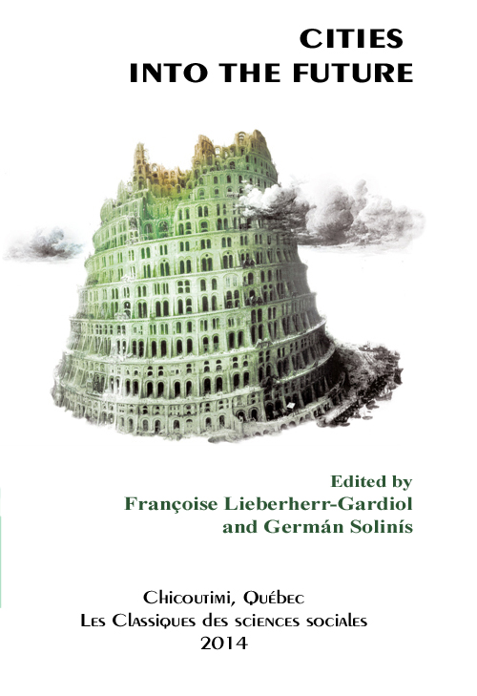

In Françoise Lieberherr-Gardiol and Germán Solinís (editors), CITIES INTO THE FUTURE. Chapter 6, pp. 210-247. A Book translated from the French version Quelles villes pour le 21e siècle ? published with the support of l’Université de Genève, la Faculté des Lettres, La Maison de l’histoire and La Fondation Hélène et Victor Barbour by Les Éditions Infolio, Suisse, 2012, 448 pp. Chicoutimi: Les Classiques des sciences sociales for the English Version, 2014, 323 pp.

The author

Adrian Atkinson, architect and urban planner, consultant to international and bilateral development organisations, member of DPU Associates (Development Planning Unit University London, UK), former professor at Institut für Stadt- und Regionalplanung, Technische Universität Berlin.

Email: atkinson@newsynergies.ch

Contents

Part II.
The emergence of regulations within globalisation

Chapter VI. Urban environment in the context of development: the case of Southeast Asia

by Adrian Atkinson

The advent of the late 20th century Environmental Movement
The process of rapid urbanisation in the South
Urban environmental problems in the South
What is being done to overcome the problems?
Urban environmental planning and management in Indonesia
Urban environmental planning and management in Vietnam
Concluding thoughts
References

Part II.
The emergence of regulations within globalisation

VI

Urban environment
in the context of development:
the case of Southeast Asia

by Adrian Atkinson

TOC
The intention of this essay is to trace the development of awareness since the final decades of the 20th century of the need to take steps to ameliorate environmental problems in the burgeoning cities of the South and what is actually being done in this respect. As will become evident as the discussion unfolds, the ‘environmental movement’ that yielded the great debate about environmental issues – and, from the mid-1980s, the ‘sustainable development’ discourse that grew out of this - has not been very interested in urban environmental problems. So the text might seem at times as if it is discussing two different sets of issues. Concerning Environment, writ large, educated citizens are aware of the global discourse that has largely emanated from the North and been transmitted to the South in great measure through the efforts of development agencies. Interventions to combat urban environmental problems have been largely parallel, rather than a consistent result of this discourse. What this essay does is to look at both these phenomena and, at the end, to try to show how they relate – or maybe should relate to one-another.
Before focusing on the present, however, it is useful briefly to look back into history and make the general remark that societies, as far as four thousand years ago, if we take the case of Mohanjo-Daro, were capable of building planned cities with regular street networks and “…high quality…sanitary arrangements…(that)…could well be envied in many parts of the world today.” The simple point is that societies can choose – in Jared Diamond’s sense – the way they organize their living arrangements. The way our global society, with its extreme liberal sensibilities, goes about planning and managing urban environments today is certainly far short of the better models left behind by history.
Even up to the late 20th century, there was an idea in currency that the organisation of society could be planned and managed coherently and we will see in the Vietnamese case presented below how, for all its shortcomings (Nguyen and Nguyen, 2007) it demonstrated that it is possible to establish coherent development policies and follow these out consistently such that we are not obliged simply to allow the development process to go where it will and then try to mop up the consequences after the fact.
What is being discussed in this paper is the consequence of the attitude that prioritises fragmented private initiative that gives us today’s chaotic, sprawling cities that would be difficult enough to manage in environmental terms even if there were a genuine commitment to do so. What we see in the rapidly growing cities of the South today is a fatal far falling short of real commitment to coherent solutions to our problematic contemporary living arrangements that do the minimum necessary to avoid the worst in the short term but avoid worrying about the longer – what look increasingly like catastrophic – consequences of these arrangements and certainly care little for the quality of the living arrangements for the vast majority of urban citizens.
We can see across the 20th century a general ‘development process’ encapsulated by the term ‘modernisation’ of which the two key, related phenomena have been industrialisation and urbanisation. From the start of the process around the turn of the 19th Century in the UK, ’development’ has been pursued as a seeking after certain lifestyle goals that seem to have landed in a high degree of mobility – through the use of cars, aeroplanes, etc. – and in the ideal of the suburban home, spreading out from cities that have grown more or less contingently across recent history. Whilst these lifestyle goals have far from been achieved by all – on the one hand because some who do have the choice, choose to live within dense (but systematically de-densifying) city centres and the majority who do not have the choice live in more or less overcrowded and insanitary informal settlements – it nevertheless gives us the form of the city we see developing today.
From the outset, as it occurred in the UK, industrialisation and urbanisation could be seen to generate environmental problems that in the first instance were tolerated but in time generated social movements campaigning for a recognition that these were genuine problems and that the public sphere should intervene to ameliorate these. This first wave of movements gave us health legislation that brought local institutions into being that were mandated and capable of taking the necessary steps to address the problems (Benevolo, 1967). This was followed by commitment of resources, coupled with technological innovations that gave us the means – classically through the organisation of water supply and sewerage systems and thence public transport – to reduce if not eliminate the problems.
Whilst there were certain break-points, amelioration did not take place all at once but followed a kind a ratchet with the rise – and once satisfied the institutionalisation - of movements, spearheaded at different times by different interests, motivating particular interventions (improvements in water and sewage treatment, investments in urban highways and, alternatively, new initiatives of public transport, etc.). As is made evident later in this paper, the environmental movement of the late 20th century was little interested in urban problems because in the North there was a sense that there were no longer any major problems in the cities to be solved but that there were serious global problems – which might involve cities but only secondarily.

The Advent of the late
20th Century Environmental Movement

TOC
The inspiration for the long wave of the ‘environmental movement’ that led to some of the initiatives discussed later in this paper starts with a series of publications in the 1960s and early 1970s. These pointed to the impossibility of indefinitely pursuing the development trajectory along which the world was heading and the need to take more heed for the use and abuse of resources and the environment (inter alia: Carson, 1962; Fraser-Darling, 1971; Ehrlich and Ehrlich, 1972; Commoner, 1972) culminating in the publication of the report of the Club of Rome, The Limits to Growth which appeared in 1972 (Meadows et al, 1972). These publications appeared in the context of public debate almost exclusively in the United States that culminated in the establishment of the US Environmental Protection Agency and the introduction of the first modern environmental management tool, the Environmental Impact Assessment (EIA).
It is important to remember that the inspiration of this movement was not simply a question of needing to improve environmental management per se but, far more profoundly than this, to change fundamentally the ideology, orientation, planning and management of the contemporary development process – being in other words social and economic rather than narrow goals concerning how to manage the environment. From the outset, however, the institutional response was one of containment, responding with improved environmental management but remaining silent of the deeper issue of the ‘development paradigm’.
1972 was also the year in which the concern for the abuse of environment and resources broadened out into an international debate through the organisation of the first United Nations conference on the environment which took place in Stockholm that year. Here for the first time North met South to discuss issues that in the first instance seemed very distant from the concerns of governments and civil society in the South. The struggle there was one to ‘catch up’ with the North or at a minimum to eliminate poverty and the preoccupation of the environmentalists to slow down on the (ab)use of environmental resources sounded as if the North could have its lifestyle but the South should learn to live frugally!
In the first instance, ‘environment’ as conceived by this movement was a global concern: that the earth’s waters and air were becoming systematically polluted, the forests depleted and in general resources being exploited to exhaustion. Urbanisation was not seen as an important issues with negative environmental consequences because, as already noted, the cities of the North seemed to work well enough. This squared also with the fact that the international development movement as supported by the United Nations and related international development organisations was paying little attention to urban problems in the South. As recently as 1992, Chapter 7 of Agenda 21, produced in the context of the UN Conference on Environment and Development (UNCED), complained that in spite of rapidly growing urban environmental problems in the South, only 1% of development assistance was going into urban settlements (Quarrie, 1992:76).
Of course the 19th Century environmental movement in the North had been about urban environmental problems and in the South there were those who with justification pointed to the fact that the more serious environmental problems in the South at this point in history were precisely urban environmental problems. This was picked up in the 1990s by the World Bank – that by then was actually spending more like 17% of its lending on urban infrastructure (World Bank, 2006a) – whose urban section coined the phrase ‘brown agenda’ to distinguish urban environmental issues from the global issues – termed the ‘green agenda’ - on which the environmental movement in the North was generally focusing its attention.

The Process of Rapid Urbanisation
in the South

TOC
There is no need to repeat in any detail here the details dealt with elsewhere in this publication concerning the rapidity of urbanisation in the South over recent decades, in most respects following in general outline the processes that took place in the North during the 19th and early 20th centuries. In summary, by the end of the 20th century most Latin American countries had urbanised in the sense that some 80% of the population was living in towns and cities rather than villages and the countryside. With the exception of the already-urbanised countries of East Asia, in both Asia and Africa, the end of the 20th Century saw a rapid process of transition under way with countries between 20 and 50% urbanised and with no exceptions to the rapid process in which parts of the rural population were either caught in villages growing into towns or migrating to towns and cities.
Initially one might talk of the urbanisation of excess rural population in the sense that there was no more space for yet more farming: rural populations were high, relative to the resource base and the technologies in use, but levelling off. However, after the turn of the century rural populations in increasing numbers of countries started to decline and, indeed, urban areas have been growing more from children born in towns and cities than from in-migration. The entity of what was being referred to as ‘urban’ was – and is – also changing. With once a relatively sharp distinction between rural and urban, increasingly cities have been spreading loosely into the surrounding countryside so that the borders become blurred and new settlements appear in ‘peri-urban’ areas some way out of the cities but with close economic ties with these.
The capacity and inclination for authorities and populations in the South to confront the negative environmental consequences of this urbanisation varies. A fascinating phenomenon in Spanish Latin America is the way in which even with little or no involvement of formal planning on the part of the authorities, peripheral developments in cities across the continent are often ‘informally planned’ on street gridirons and even with spaces left for social infrastructure on the assumption that some time in the future this will be built. One can only conclude that there is a kind of cultural ‘tacit knowledge’ inherited from the fact of planned cities from the early days of Spanish colonialism. By contrast, in so far as authorities in much of Asia and Africa only manage to control the location of part – in some cases only a relatively small part – of the urban expansion, this occurs spontaneously on a basis that can often be seen to be an inheritance of the rather informal way in which rural settlements are organised. In urban areas this results in more or less severe dysfunctionality that one can in general define in terms of ‘environmental problems’.
Thus, over the past decades, authorities that earlier in the 20th century were assumed to take all the decisions and make the investments necessary to organise urban growth systematically relinquished or lost control and increasingly the organisation of much of the urban space and process became spontaneous, referred to as ‘informal’. This didn’t always mean no-organisation and much work has gone into studying the varying processes of ‘informal developers’ and community self-organisation . It is important to keep in focus this general retreat of governments and failure of local governments to address growing environmental problems.
Significant blame for this has been laid at the door of the international development ideology of neo-liberalism and the prejudice that this brought with it towards governments proactively planning and organising the development process. Whilst the problems dealt with here certainly predate the implementation of ‘structural adjustment’ and related measures of the international financial organisations (IFIs), the tendency in these to call for reduction in government programmes inevitably left a failure of confidence in planning and action where it came to coherent approaches to urban development.
Whilst it is true that towns and cities were and are growing at a pace far outstripping the financial capacity of the authorities to provide housing and infrastructure – even with substantial IFI loan support and development donations – during the 1980s and on into the 1990s, development priorities were focused predominantly on income-generating activities to pay off debts and organise some kind of economic growth such that looking after the environment – and indeed social needs of the urbanising population – remained largely out of focus.

Urban Environmental Problems in the South

TOC
So what are the environmental problems that have arisen under these circumstances? It is useful to make reference to the substantial work of Hardoy, Mitlin and Satterthwaite (1992, 2001) in their comprehensive survey of urban environmental problems in the South and the following paragraphs derive in part from this analysis.

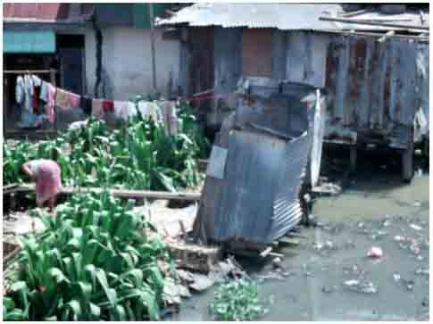
Photo: Adrian Atkinson

First we need to look at the consequences of the poor environments that are to be found in cities throughout the South today and especially in areas which have been developed informally – occasionally neighbouring on industrial areas and more often on roads and heavily polluted waterways that directly affect the health of those living and working under these conditions. Poor environments lead to environmental health problems that include particularly diarrhoeal and other water-related diseases and to respiratory disease. The world health organisation estimated in the early 1990s that some four million children were dying annually from contaminated water and food induced disease with hundreds of millions suffering from intestinal parasitic infections. Whilst respiratory disease is less likely to kill, it was and is debilitating hundreds of millions of people living or working in air-polluted urban environments (WHO, 1992).
Whilst every urban citizen must obtain water in order to survive, in few cities in the South is the water supplied to all homes. For many this is supplied via neighbourhood standpipes and large populations must buy water from vendors at a price considerably above what is paid by generally richer people in formal housing. There are few cities in the South where water supplies by any of these means provide water fit to drink. Sanitation arrangements are generally poor with inadequate and sometimes non-existent sewer systems or sewage treatment. 2008 was the International Year of Sanitation and the WHO/UNICEF (2008) Joint Monitoring Report on Water and Sanitation for this year indicated that some 20% of the world’s urban population lacked at that time improved sanitation arrangements with the figure for South Asia of over 30% and sub-Saharan Africa approaching 60%.
Although in recent years, in the framework of the Millennium Development Goals, the percentage of population without improved sanitation has been increasing, this has been at a rate which, if continuing, will not meet the Millennium Development Goal of halving the numbers of people without adequate sanitation between the year 2000 and 2015. ‘Improved sanitation’ in urban areas is, furthermore, still some way short of a full sewerage system with even basic treatment. For example, in the early 1990s, where 26% of sewage in the city of São Paulo was treated and 20% in Accra, only 1% was treated in Jakarta (McGranahan et al, 2001, Table 4.4). Figures have not improved substantially since then. The result is that both groundwater and all surface waters within most cities in the South are heavily polluted, spoiling these as sources of usable water or for recreation and contributing substantially to ill-health.
Very many southern cities suffer regular flooding, particularly – but not exclusively – in areas where the poor have settled illegally – indeed flooding in Bangkok, Ho Chi Minh City, Jakarta, and Manila over the past five years seems to indicate a rapid worsening of the extent of urban flooding at least in Southeast Asia. Whilst people adapt to floods as an inconvenience, these generally contaminate fresh water sources exacerbating the incidence of disease and in extreme case cause of deaths. It should be emphasised that most urban flooding results from ongoing urban development including surface sealing and subsidence due to over-extraction of groundwater. Informally dumped solid waste constricts drainage channels but generally in any case planning and investment in drainage is inadequate to deal with the problem or can even, as in the Bangkok case exacerbate the extent of flooding in some areas in order to protect others.
Related to this is the incidence of landslides brought on by heavy rain and land saturated in informally disposed of wastewater. Cities where informal settlements are built on slopes are particularly prone to this hazard which from time to time results in destruction of houses and deaths. A further significant hazard is presented by the incidence of earthquakes. Building technologies are available to resist destruction in even strong earthquakes but these are disregarded altogether in many southern cities and certainly by those building their houses informally. An extreme case occurred in the suburbs of Jogjakarta in May 2006 where some 335,000 houses were partially or completely destroyed by a relatively mild earthquake, as a consequence of the misuse of modern materials – inadequately fixed bricks and roof-tiles (Atkinson, 2007)
Solid waste disposal is also generally poor in southern cities with – to take the same three examples from the early 1990s as above (ibid) – 90% being collected in São Paulo, 83% in Jakarta and 75% in Accra with most of this disposed of in insanitary ways. In smaller cities and everywhere in peripheral areas of larger cities there is little or no collection and waste accumulates where it is dumped into waterways or on unused open land where it is sometimes burned, adding to air pollution. Some of the waste is informally recycled making a living (not always the least remunerative) for a segment of the poorer population. Although a few local authorities recognise this as a legitimate activity and assist in providing suitable clothing, generally the activity is one – albeit among many in the informal economy – that is particularly hazardous to health.
The direct relationship between urban air pollution and morbidity and death rates is difficult to establish precisely but city statistics do indicate a general relationship (Hardoy et al 2001:99-101). Extreme examples are provided by industrial cities (the most notorious being the city of Cubatão, neighbouring São Paulo) but traffic in large southern cities – in some cases exacerbated by periodic inversion weather conditions – also take their toll. One estimate for Latin American cities indicates some two million children as suffering chronic coughs and some 24,300 premature deaths a year whilst 20,000 premature deaths a year is the estimate for just four large Chinese cities.

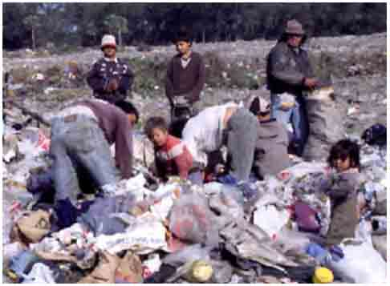
Thailand: Photos: Adrian Atkinson

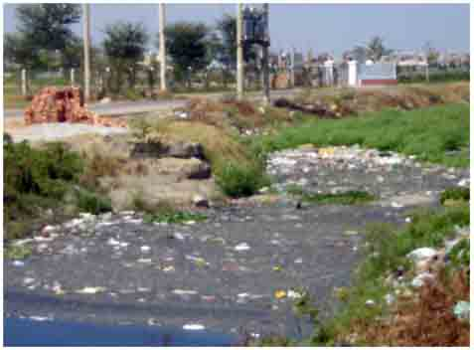
Thailand: Photos: Adrian Atkinson

Much is being discussed today about the threatening impacts of global warming and although it is the inhabitants of the northern countries that have most to answer for in producing the ‘greenhouse gases’ that are generating the phenomenon, the sprawling nature of southern cities is also associated with growing dependence on petrol vehicles which, whilst not generating concentrated local air pollution, contribute to global warming. Further impacts of global warming can be expected in the future in the form of increased and more frequent flooding and sea-level rises that will add to this in the many cities located on the sea that could, in the not too distant future, lose much of their developed land permanently.
It is sometimes thought that industry is a major source of urban pollution – and the case of Cubatão was mentioned above. Whilst industrial pollution in the South is generally poorly managed and, where industries are using toxic chemicals these can contribute insidiously to local poor health, most urban pollutants originates from dispersed sources and actions right across the city and into the surrounding region. Thus polluted water is due to households with inadequate sanitary conditions and poor sanitary practices, most flooding is due to poorly or unplanned urban development and air pollution could be greatly ameliorated if not eliminated by systematic regulation of vehicle exhausts. Besides air pollution, poorly conceived urban transport systems dominated in terms of the use of road space by the automobiles of the few who can afford them, together with poorly regulated mini-bus and related informal public transport systems, lead to accident-prone and congested traffic making the cities difficult to move around.

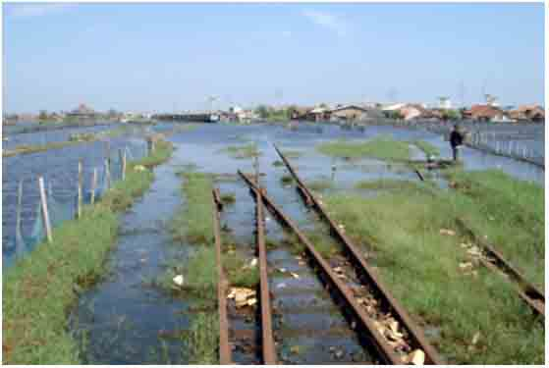
Semarang, Indonesia: Photo: Ulrich Ranke

All these problems can be greatly mitigated or eliminated with relatively small changes in citizens practice and relatively simple technologies which, however, need to be consistently implemented and which in some cases require significant sums of money which governments are unwilling to raise by taxation or borrowing. But this is not simply political resistance, there is also the broader question of human resources: the quality of political decision-making and adequate knowledge all the way from decision-makers and government staff down to the ordinary citizen whose everyday practices contribute to the problems.

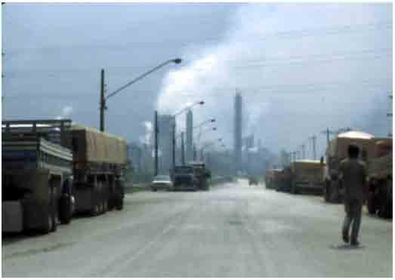
Cubatão, Brazil: Photo: Adrian Atkinson

What is being done to overcome
the problems?

TOC
Over half the cities of over one million population in the South and many smaller towns and cities were founded under the colonial rule of the Europeans and in the early 20th century were built to European specifications with water supply and in many cases with sanitary sewers and tramway systems. Informal settlements had started to appear early in the century but it was with few exceptions only in the 1950s and 1960s that these became a notable feature of southern cities. Furthermore, infrastructure investments generally increasingly lagged behind development – in many cities investment for instance in extending sewer systems of public transport simply ceased.
Combating deteriorating urban environmental conditions in the South has in few cases been a predominantly indigenous initiative. As discussed earlier in this paper, the growing problems have appeared and worsened in the context of rapid urbanisation, increasingly within the framework of liberal ideology and particularly structural adjustment conditionalities, reducing the effectiveness of government initiatives. Ironically this has resulted in the IFIs, the United Nations and bilateral assistance organisations and latterly international and local non-government organisations (NGOs) pushing and in many cases leading the search for and investment in solutions.
Southern governments initially reacted to growing unplanned settlements by attempting to demolish them as not conforming to their image of development (Hardoy and Satterthwaite, 1989). However, as these were often not only immediately rebuilt and also added to with further settlements, there emerged a resignation to the fact of informal settlements and eventually to a commitment to in-situ solutions to the accompanying environmental problems. The IFIs that initially lent small amounts to governments to finance urban infrastructure and low-cost housing – which generally fell into the hands of the not-so-poor – then turned to loans and grants to install water supply, sanitation and other environmental improvements in already-existing informal settlements.
These programmes were already underway in a few countries when the environmental movement made its appearance. The impact that the movement then made was not particularly noticeable. On the one hand most countries adopted umbrella environmental laws and thence various regulations and institutional initiatives arose in the form of new Environment Ministries and Agencies. Whilst having a relatively loud voice and often being allocated staff more committed and capable of seeing the problems clearly, these were – and remain – relatively marginal within the overall spectrum of Government, that is to say they have mostly been allocated small staffs and budgets.
In some countries provincial and/or local environmental agencies have also been established. The focus of these has been predominantly on global and national environmental problems (the green agenda) with responsibilities regarding the brown agenda remaining mainly in the hands of Public Works or equivalent Ministries and their line agencies at the regional and city level. Environment ministries mounted small, focused campaigns – often with support of the IFIs and/or other external development organisations – such as concerning reduction of urban air pollution and disposal of industrial waste.
What the environmental movement did bring to the process was not so much to do with the environment as a concern for the insensitivity with which the international agencies had been delivering their solutions. ‘Participatory planning’ began to replace technocratically delivered solutions in the mid 1980s. These were offered as pilot projects by various development agencies and institutions at first in rural areas as ‘Rural Rapid Appraisal’ (Chambers, 1983), ‘Participatory Action Research’ (Rahman, 1993) and under yet other titles. After UNCED, urban oriented participatory planning initiatives came under the title of ‘Local Agenda 21’. The World Bank, on its part, launched such projects in a number of Asian cities under the title of Metropolitan Environmental Improvement Programme (MEIP) and in conjunction with that experience changed from ‘squatter settlement upgrading’ to ‘community upgrading’ (Viloria-Williams, 2006).
The mechanism used by external development agencies to organise participatory processes was Non-Government Organisations (NGOs). What has been termed the ‘rise of civil society’ grew out of unorganised movement experiences on the 1960s that, in the course of the 1970s and 80s took on formal structures around a variety of issues (Brand, 1985; Princen and Finger, 1994). The environmental movement was certainly prime amongst the ‘new social movements’ in the North and this was to an extent reflected also in the South. On the other hand, the formation of NGOs could also be said to have been promoted to a significant degree from funding by external agencies to manage participatory processes in project delivery (Cernea, 1988; Brown and Korten,1989).
The following two sections are intended to illustrate in a little detail how, in the case of two countries in Southeast Asia, Indonesia and Vietnam, urban environmental problems have emerged, the initiatives that have been taken in trying to overcome them and the results as we see them today .

Urban Environmental Planning
and Management in Indonesia

TOC
In several respects Indonesia responded relatively early both to the fact of deteriorating urban environmental conditions resulting from the spread of informal settlements and to external pressure to take a more coherent approach to environmental problems. In fact the Dutch colonial Government had already taken what we now think of as urban environmental initiatives in the 1930s. This is worth mentioning because what was then referred to a ‘nuisance legislation’ concerned with environmental health has continued to this day to form the basis of many effective - and some less effective - urban environmental health measures in urban Indonesia.
On the other hand, informal settlements also began to emerge in Indonesian cities in colonial times and a small programme was started to ameliorate the conditions in these. This history surely encouraged the independent Indonesian government to develop a consistent approach to the amelioration of environmental conditions in informal settlement under the title of Kampung Improvement Programme (KIP) – ‘Kampung’ being Indonesian for village – involving the World Bank. This started in Jakarta in 1969 (Suselo and Taylor, 1995:13; Viloria-Williams, 2006:79), and thence with the Asian Development Bank and a number of bilateral development agencies joining the World Bank, dividing up the cities and financing further programmes. The intention was as far as possible to avoid demolition and undertake work to surface walkways, provide drainage and water supply through standpipes as well as building communal toilet and washing facilities. Eventually over 300 cities and towns were served by the World Bank programme alone and countless further programmes that eventually included local NGO initiatives made improvements to the living conditions of many millions of poor urban citizens.
Following the major programmes in Jakarta and Surabaya, a broader programme of general urban infrastructure provision was initiated under the title of Integrated Urban Infrastructure Development Programme (IUIDP) that financed infrastructure ‘packages’ covering water supply, sewerage and human waste management, improvements to solid waste management, drainage and flood control, urban roads and market improvements to public markets (van der Hof and Steinberg, 1992; Suselo et al, 1995). These programmes were accompanied by the production of basic urban plans and integrated improvements to informal settlements following a simplified KIP approach.
After the larger cities had been covered, smaller cities and towns were dealt with in clusters. The mechanism for delivery of the plans was consultancies over two years or so followed by bank loans over numbers of years to carry out the work. Under the impact of the growing concern for a more coherent approach to the environmental dimensions of the programme, from the mid 1990s IUIDP projects were required to include an environmental assessment both of the pre-existing situation and of the measures to be undertaken .
It becomes necessary to ask what the overall impact was and why it is that one can find small and large settlements in Indonesian cities that still merit no better name than slum. There are, broadly speaking two reasons for this. The first concerns the sheer rapidity of the urbanisation process and the lack of the kind of investment that would have been necessary to eliminate these conditions. The authorities looked enviously at the transformation of Singapore next door that also started independent life with significant slums but managed to create what some feel to be an all too clean and tidy urban environment! The reason was, of course, that Singapore is now a rich country and Indonesia remains a relatively poor one: the resources available for urban improvements have been strictly limited.

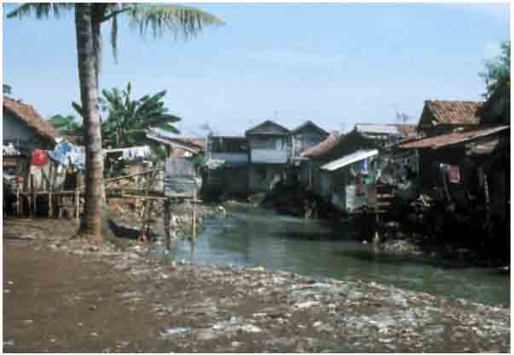
Jakarta: Photo: Adrian Atkinson

But it is also possible to point a finger at the mode of delivery of the programmes – that in spite of the legislation were, until well into the 1990s (and with the notable exception of the Surabaya experience) severely top-down with no genuine participation. This resulted a lack of ‘ownership’ and hence maintenance such that in many areas improvements rapidly deteriorated. Later programmes, where communities were encouraged to participate in decisions as to what improvements should be made, demonstrated how, with very modest means and local commitment, some slums could be transformed into pleasant urban neighbourhoods.
The Surabaya case pioneered the change in procedure that involved populations prior to any decisions being made concerning environmental improvements. This was clearly the result of a constellation of local decision-makers able to find their way through what was a highly centralised government system as well as the initial World Bank procedures. The Bank itself also initiated a learning process through the MEIP, mentioned above which included Jakarta. The ‘community upgrading’ which this introduced in pilot areas that included social and economic development components in parallel with infrastructure improvements pointed the way to subsequent approaches to the upgrading of informal settlements. However, as noted above, local environmental problems remain, including poor quality water supply, inadequate waste management – in Jakarta, waste collection oscillated across the 1990s between 78% and 88% - and for much of the population regular flooding of neighbourhoods that resist solution without much more substantial resources and strategic investments together with a better quality of urban management.

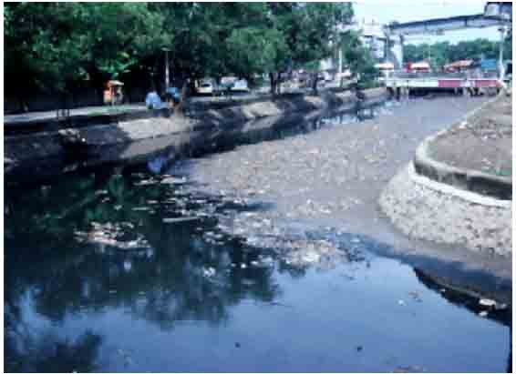
Jakarta: Photo: Adrian Atkinson

The impact of the advent of environmentalism internationally resonated in Indonesia with a comprehensive environmental law introduced already in 1982, a Ministry of Environment and then in 1990 an executive Environment Agency. Numbers of critical environmental NGOs were formed, foremost being the more politically engaged umbrella organisation WALHI and the more scientifically-inclined Pelangi. For many years the Ministry was led by Emil Salim who had both an international reputation as ‘environmental activist’ and pursued a forceful set of policies aimed to insert environmental concerns into the development process. He actively cooperated with the environmental NGOs, some of which collaborated whilst others preferred to keep their distance from government.
Relatively little of the policy framework was directed towards urban issues, and the style was generally one of campaigning, given the failure of the Ministry to gain access to influencing the national budgetary process. A national Agenda 21 was compiled with UNDP assistance that made little practical impact and what integrated local environmental campaigns or programmes of the Local Agenda 21 kind did occur – such as in Surabaya (Atkinson, 2001) - were motivated by external funding rather than indigenously generated.
Among the Ministry-instigated campaigns, the PROKASIH programme aimed at improving pollution control of industries that were discharging wastes into rivers and the ADIPURA programme has given annual prizes to urban authorities that achieved a certain level of cleanliness of their city. Urban air pollution was also seen as a growing problem that attracted small externally-financed projects. Initially the World Bank URBAIR programme was implemented in a number of Asian cities (Shah et al, 1998) paralleled by the German-funded MERKAL study (Kleemann,1994) carried out in conjunction with the national scientific foundation BPPT followed more recently by the EU-funded CURB-AIR initiative. Whilst considerable information has been compiled, these have tended to remain at the level of policy-making and pilot projects.
A radical process of decentralisation of powers, responsibilities and significantly also of resources to local authorities – bypassing the provinces – that was introduced in 2000 is enabling a locally more sensitive approach to urban environmental management to take shape. In the first instance, however, the results were very patchy, where ‘local democracy’ is something that takes time to be learned and where some local authorities used their power and resources more competently than others. At its best decentralisation has led to substantially increased efforts to make local environmental improvements – such as the Surabaya environment department established in 2001 – that is collaborating with local NGOs and aggressively seeking external finance for environmental management projects (Kono, 2004).
Where the economic crash of 1997 raised the spectrum of a new impoverishment of a country that had over decades struggled to reduce poverty and its environmental effects, since the turn of the century, there has been a feeling, reflected in urban environments, of a sense of increasing tidiness even of poor urban neighbourhoods which may in part be put down to the fact of one-time rural migrants having learned how to organise their new life in cities with very modest resources, with the encouragement of government programmes and the assistance of committed local NGOs. The long-term sustainability of these development is, however, nowhere on the agenda and attempts to focus on these have gained no response amongst local academics or responsible authorities (Atkinson, 1993).
Since 2006, when climate change hit the international agenda, there seems to have been a new impetus to urban environmental management, complete with new injections of international finance and even involvement of the private sector to benefit from carbon credits. In general the issues have been, as everywhere, mitigation of greenhouse gas emissions and adaptation to the impacts of climate change. In 2006, President Susilo Bambang Yudhoyono declared the national greenhouse gas (GHG) emission reduction target of 26%, following which a national board was establisged to come up with the National Action Plan Addressing Climate Change (RAN-MAPI). Aside from its major focus on reducing emission from deforestation and forest degradation the plan, issued in 2007, includes several sectors to be dealt with in the urban context including waste management and reduction in energy consumption . The National Development Planning Board (Bappenas) then develops RAN-MAPI into an annual roadmap, breaking down GHG emission targets into practical projects by sector (Bappenas, 2010).
The Ministry of Public works has been responsible for transmitting the road map to achieve local targets at provincial and city level. This has meant building new measures into the urban special and master planning processes. Infrastructure projects aimed at mitigation include installation of energy-saving city lighting and use of carbon credits to improve the management solid waste disposal sites. On the adaptation side, new impetus is being put into flood control measures – for instance with the World Bank investing in new measures in Jakarta under the title of Jakarta Urgent Flood Mitigation Project. However, as elsewhere in the region, whilst urban flooding is evidently increasing in seriousness, indications are that this is so far not due to climate change-induced sea level rise but rather to urban development problems which urgently need taking in hand if low-lying neighbourhoods of the coastal cities are not to become uninhabitable in the foreseeable future.

Urban Environmental Planning
and Management in Vietnam

TOC
The contemporary idea of ‘environment’ came late to Vietnam as did the process of rapid urbanisation. As a divided country until the end of the war in 1975, urban development occurred in entirely different ways in the north and the south and the legacy of this is still discernable . In the north, the government had definite policies for the containment of Hanoi – whilst also asserting it as a large city on the scale of what was Saigon – and developing satellite industrial towns within about a one hundred kilometre radius of the capital. But the urban population remained well below 20%. In the south, little was done by way of planning and the fact of rampant influx of war refugees into what is now Ho Chi Minh City (made up of the cities of Saigon and Cholon) as it was thought that after the war these migrants would return to the countryside.

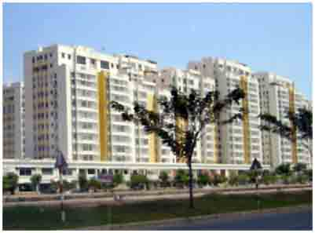
Photo: Nguyen Viet Thang and Adrian Atkinson

Once the country was unified, the south, too, came under the erstwhile policies of the north and it was not until the mid 1990s, in the framework of the introduction of liberal policies and greater freedom for people and businesses to move and develop as they saw fit, that urbanisation began to take off. By the year 2005 the population exceeded 26% of the national population – itself growing fast – and it is estimated that by 2030 the urban population will be over 40%. Recently the urban population has been growing at about one million inhabitants a year (Coulthart et al, 2006).

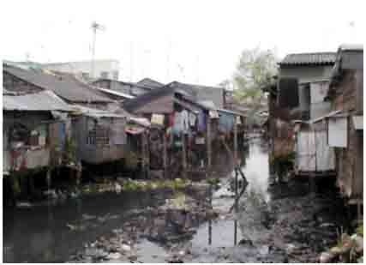
Photo: Nguyen Viet Thang and Adrian Atkinson

During and immediately following the war, the focus of the Government was entirely upon security and thence economic development with very little attention and resources directed to urban infrastructure or housing. This left a backlog of needs in terms of water-supply and sanitation that, with the rapid growth of cities, is difficult to catch up in spite of there now being an awareness of the need (Warlters, 2006). Meanwhile, housing provision is now predominantly the responsibility of the private sector. Some large housing estates are being built but a large proportion of the housing is built individually and ranges from a reasonable quality to classic slum housing – of which the World Bank estimates there are some 300,000 units in Ho Chi Minh City but which can be found in significant numbers also in other cities. Urban planning remains locked in a framework inherited from communist times that is far too rigid to be capable of directing development particularly on urban peripheries and in consequence development is becoming scattered over wide areas particularly in the metropolitan regions. This is difficult to serve with infrastructure and as these areas densify, so the environmental problems escalate.

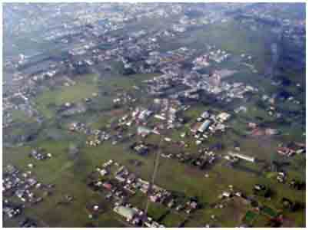
Photo: Nguyen Viet Thang and Adrian Atkinson

Small slum-upgrading pilot projects have been undertaken – one of the most visible being the Tan Hoa Lo Gom Canal project in Ho Chi Minh city, financed by Belgian assistance (Verschure et al, 2006). The World Bank, Asian Development Bank (ADB) and bilateral agencies – notably Ausaid, Agence Française de Dévéloppement (AFD) and Japanese assistance (JBIC) – have been helping to finance and develop basic urban infrastructure. Coordination amongst these external agencies was formalised with the creation of the Vietnam Urban Forum in 2001 with the Vietnamese government (Ministry of Construction) taking ‘ownership’ of it in 2003. However, the Vietnamese government remains resistant to recognising the spread of slums because these are seen as substandard and thus in principle should be demolished and replaced with housing of a higher standard. The fact remains, however, that Vietnam remains a very poor country – with GDP per capita considerably less than half that of Indonesia - and the resources simply are not present to build better quality housing for the poorer population.
A classic case is presented by Nhon Trach new town to the west of Ho Chi Minh City (Tuan, 2007). This was planned as an integrated industrial suburb in the context of the successful attraction of inward industrial investment. Land was made available for industry, housing and centre city functions and industries came to locate in the industrial area. However, the standards set for the housing areas were far higher than could be afforded by the working population and the (informal) services that settled in proximity with the areas where the workforce came to live. As neither the industries nor the government provided any housing, this appeared as informal development expanding the neighbouring villages into what became a town with the official housing land remaining almost entirely empty in spite of the presence of roads and other infrastructure. The environmental conditions in the informal villages included heavily polluted local streams from waste water and informally disposed solid waste.
Besides serious water pollution problems – and it should be added, notable problems of inadequate solid waste management – in the growing cities, there is a rapidly growing problem of air pollution partly from industry but particularly from traffic. As recently as the mid-1990s, urban roads were dominated by bicycles. Following the turn of the century, motorcycles came within the financial capacity of large sections of the population and these, together with a growing volume of cars, rapidly displaced bicycles, reaching a crisis in terms of traffic management and serious air pollution by 2005. Whilst air quality monitoring is ongoing in the major cities, policy directives have been promulgated and the both the national Environmental Protection Agency and local authorities in the larger cities have been formulating means to control the problem, effective solutions to what is an growing problem have yet to be implemented.
A further serious problem particularly in coastal cities and above all in Ho Chi Minh City is flooding. This is a regular and increasing occurrence as a consequence of the continued sealing of surface area and the lack of adequately coherent drainage. However, this will almost certainly increase as a problem due to changing weather conditions and with half the city less than one metre above sea level, the defence of the city against permanent inundation is a question that until 2007 had not been apprehended by the government. Although there had been increased concern with flooding it was only after from 2008 that numbers of studies were undertaken to analyse the nature and possible future of urban flooding problems and what steps need to be taken to mitigate these.

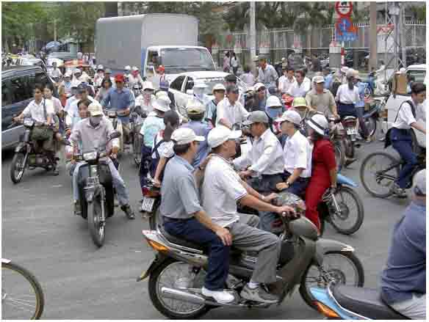
Hô-Chi Minh City: Photo: Adrian Atkinson

The national government acknowledged the problematic of climate change and the urgent necessity to consider the impacts of this in the coming years on Vietnam in the passing of Decision 158/2008/QD-TTg in December 2008. This, however, made little reference to urban flooding as a specific problem and one which needs urgent attention in the case of Ho Chi Minh City. By 2010 a number of studies had been undertaken both to outline measures that could be taken to reduce the flood risk of the city and also assessments of how effective these might be (ADB, 2010; Gravert and Wiechmasnn, 2011). As in the case of Jakarta – indeed, with even more dire consequences – it is clear that ongoing urban development, particularly in very low-lying areas – is already resulting in very regular flooding and with ongoing development, even with the proposed mitigation measures, significant areas of the city are likely to become uninhabitable within the coming decades. This is not reflected i n the present urban and regional plans but might be expected to result in plan amendments in the coming years.

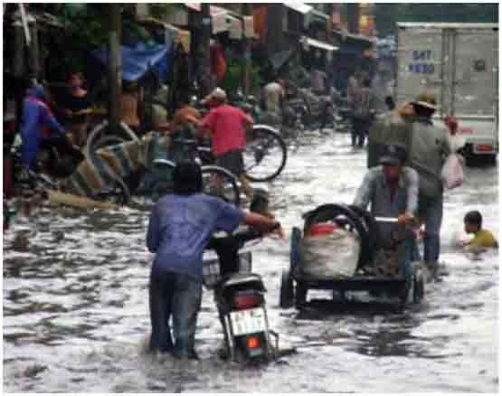
Ho Chi Minh City: Photo: Nguyen Viet Thang

Returning to the question of urban environment as a policy and institutional issue, it was noted at the outset of this profile of Vietnamese urban environmental planning and management that the country came late to the subject. During the communist years, environment was not an issue in itself and the first coherent recognition of this by the government was the adoption of the Environmental Protection Law of 1994 following creation in 1993 of the Ministry of Science, Technology and Environment (MOSTE), along the lines of the Thai Ministry of the same name. This remained a small and weak Ministry until its replacement in 2003 by the Ministry of Natural Resources and Environment (MONRE), again following Thai precedent and the arrangements that had been in existence for over a decade in the Philippines. The environmental protection law was thoroughly overhauled in 2004.
As in the case of urban infrastructure development, environmental planning and management has been dominated by external assistance from a large number of international and bilateral agencies. During the 1990s assistance was given both to generate strategic documents – including the first National Environment Strategy and Action Plan – and to provide technical training and assistance to the provincial environment offices (DOSTE) particularly to empower these to control industrial pollution, given the rapid inward investment of large industrial plant. It became clear that environmental issues remained on the margins of government decision-making and UNDP supported a Capacity21 project linking MOSTE with the Ministry of Planning and Investment (MPI) in an attempt to get environmental considerations incorporated into economic planning from the outset. Similar attempts were also made in some cases at the provincial level.
These attempts did not make a significant impact, with the national planning system involving nested socio-economic plans followed by urban and regional physical plans under the Ministry of Construction and environmental planning and other initiatives taking place on the margins. The importance of this is that economic development is promoted and the national budget directed towards this with relatively little regard for environmental – or indeed social - consequences. In spite of strategic policy documents – the most recent being the National Strategy for Environmental Protection and Strategy for Sustainable Development (Agenda 21) – action on environmental issues is carried out largely to mitigate the consequences of development rather than to guide it. Of course the market orientation of Vietnamese development today means anyway that plans of all kinds have diminishing directive power and it is a combination of private sector negotiations and rampant ‘informal’ development that create the reality on the ground – and the environmental problems which come with this.

Concluding Thoughts

TOC
There are really two perspectives on where we stand today with regard to urban environmental problems and what has been achieved in trying to mitigate these. On the one hand the present concern for ‘environment’ clearly originates in the analyses of the later 1960s and early 1970s that gave birth to the international environmental movement with its strategic concern for the abuse of the global environment in all its dimensions including the spoliation and exhaustion of resources. Today this concern falls under the heading of ‘sustainability’ and ‘sustainable development’. The other perspective is one that has a narrower focus, concerned with living conditions in urban areas that deals particularly with human health and in principle also the efficiency and convenience of cities. Crudely speaking we can say that the latter perspective is short-term and the former long-term.
There is no universally recognised comprehensive set of urban environmental problem indicators and monitoring to say where we stand and how well we are doing to combat the problems. In one area – what might be considered to be the core area of ‘improved’ urban sanitation – we do, however, have such a global assessment in the form of the Millennium Development Goal for sanitation and the Joint Monitoring Programme reports where we see that progress is being made in the provision of sanitation for urban populations but that this is not keeping pace with the growth in urban population (WHO/UNICEF, 2008:10).
This seems to represent quite well the situation we find in the two countries here looked at in detail. However, in the case of South Asia and particularly Africa, the sanitary situation falls far short of the goal. Furthermore this measure does not yet look beyond the toilet at whether and to what degree the waste is being treated and hence what the impact is on the quality of ground and open surface water in and around the cities – and the health dangers that this poses.
As we have seen in the cases of Indonesia and Vietnam, flooding is a further problem which we know to affect large numbers of cities and within those cities particularly the poor whose settlements locate in places liable to flooding because no formal developer would choose to build there, making eviction unlikely. They are prepared to take the risk and suffer the consequences that are mostly a question of inconvenience rather than being fatal . This situation is probably much like the situation with regard to sanitation: that measures are being taken to improve drainage in most cities but that the rapid urban development – both formal and informal – means having to run fast to stand still and until urbanisation is more or less complete, this will continue to be a losing battle.
The evidence for the problem of urban air pollution also has, as in the case of flooding problems, to be more anecdotal. Certainly, the cities of Latin America where in the 1980s inversion conditions led to major crises of weeks where the air became dangerous to breathe death rates rose significantly. This situation led to measures being taken in many cities to control the problem. Possible ameliorative measures are well-enough known and it simply took political will to confront the issue, which is far from eliminated, but brought to a level where it no longer represents a political problem. One would like to think that this could follow the European case where, once urbanisation rates have stabilised it is easier to focus on step by step measures to improve the environment.
Or we can take one step back and take issue with the attitude that lets things happen up to a crisis point and then does just enough to avoid political repercussions. If we reflect in this way then a whole host of questions arise as to why the means cannot be found to organise the social process, of which current rapid urbanisation is one facet, in a way that foresees the problems we are facing and deals with these in a organised fashion where in almost all cases workable solutions are known and where it is, again, a question of political will to plan and to resource the solutions. The problems of abuse of water resources, of avoiding contamination or of treatment, of drainage and how to build cities to avoid flooding, of air pollution and how not to produce it or if produced how to eliminate it: all these can be solved. But we live in times where all this knowledge is disregarded as running counter to the liberal pursuit of individual happiness as defined through the evolution of processes of consumption in a world where those able to convince populations to consume what they have to offer are king.
This brings us back to the start of the essay, not just to the fact that societies have existed that did have an organised approach to urban development based on notions of what makes a good environment (we can’t necessarily vouch for whether these populations were therefore happier or not), but to the concerns and aspiration of the environmental movement of the late 1960s and early 1970s. Whilst we might be able to see a process of amelioration of immediate local environmental problems that could emerge in time in the cities of the South once the urban environmental managers do not have to run so fast just to stand still, this vision falls to pieces when we start to look into the longer term that was the concern of the original environmental movement. We simply cannot continue to develop in this way: it is simply unsustainable!
Certainly the World Bank and a widening range of international agencies and institutions are coming to focus on the emergent problems connected with global warming and to support what it terms ‘adaptation planning’ to anticipate the problems that will be arising and as far as possible to avoid them – but understanding full well that the consequences are likely to be dire . What has yet to be focused upon is the impacts not of a voluntary reduction in the use of energy from fossil fuel to reduce global warming but of a reduction that will be happening anyway as a consequence of depletion. The impacts that this will have on urban life everywhere will be devastating (Atkinson, 2008). We might say that the main problems will be economic rather than environmental: that energy prices will rise inexorably and as almost everything within the modern economy has a component that derives from petrochemicals, so the price of almost everything will rise. Under these circumstances, however, today’s cities will become unworkable in ways that we can only speculate on.

References

TOC
ADB (2010) Ho Chi Minh City Adaptation to Climate Change, Manila : Asian Development Bank.
Atkinson, A. (1993) “Are Third World Megacities Sustainable ? Jabotabek as an Example”, Journal of International Development, 4, 2.
Atkinson, A. (1998) Developments in Urban Environmental Planning and Management in Indonesia: The Secondary Cities of Sulawesi, DPU Working Paper No.86. London : Development Planning Unit, University College.
Atkinson, A. (2001) “Surabaya, Indonesia: Local Agenda 21 in the Context of Radical Political Reform”, City, 5, 1, p. 47-65.
Atkinson, A. (2007) Grassroots Action to Address Emerging Sustainability Threats to Cities in the South, 8th N-AERUS Conference, London : Development Planning Unit.
Atkinson, A. (2008) “Cities after Oil-3: Collapse and the Fate of Cities”, City, 12, 1, p. 79-106.
Atkinson, A. (2012) “Urban Social Reconstruction after Oil”, International Journal of Urban Sustainable Development 4, 1, p. 94-110.
Atkinson, J.F.K. (ed.) (1997) Urban Environmental Management in Southeast Asia: An Overview of Current Practice, Eschborn : Deutsche Gesellschaft für Technische Zusammenarbeit (GTZ).
Bappenas (2010) Indonesia Climate Change Sectoral Roadmap – Synthesis Report, Jakarta : Bappenas.
Benevolo, L. (1967) The Origins of Modern Town Panning, London : Routledge and Kegan Paul.
Brand, K-W. (1985) Neue soziale Bewegungen in Westeuropa und den USA: Ein internationaler Vergleich, Darmstadt : Wissenschaftliche Buchgesellschaft.
Brown, L.D. and Korten, D.C. (1989) Understanding Voluntary Organizations: Guidelines for Donors, Boston : Institute for Development Research.
Carson, R. (1962) Silent Spring, Boston : Houghton-Mifflin.
Cernea, M. (1988) Nongovernmental Organisations in Local Development, World Bank Discussion Paper No.40, Washington DC : World Bank.
Chambers, R. (1983) Rural Development : Putting the Last First, London : Longmans.
Commoner, B. (1972) The Closing Circle, New York: Bantam.
Coulthart, A., Nguyen, Q. and Sharpe, H. (2006) Urban Development Strategy : Meeting the challenges of rapid urbanization and the transition to a market oriented economy, Hanoi : World Bank.
CURB-AIR (2008) The Clean Development Mechanism and Urban Air Pollution : A Handbook for Policymakers, LINK.
Diamond, J. (2005) Collapse: How Societies Choose to Fail or Succeed, New York : Viking.
Douglass, M., DiGregorio, M. and al (2002) The Urban Transition in Vietnam, Honolulu :
Department of Urban and Regional Planning, University of Hawai’i, and Fukuoka : United Nations Centre for Human Settlements (UNCHS).
Ehrlich, P.R. and Ehrlich, A.H. (1972) Population Resources Environment (Second Edition), San Francisco : W H Freeman.
Fraser-Darling, F. (1971) Wilderness and Plenty, New York : Ballantine.
Gavert, A. and Wiechmann, T. (2011) Climate Change Adaptation of Urban Planning in the City of Region of Ho Chi Minh City, Megacities Research Project TP, Ho Chi Minh : HCMC.
Hardoy, J.E., Mitlin, D. and Satterthwaite, D. (1992) Environmental Problems in Third World Cities, London : Earthscan.
Hardoy, J.E., Mitlin, D. and Satterthwaite, D. (2001) Environmental Problems in an Urbanising World, London : Earthscan.
Hardoy, J.E. and Satterthwaite, D. (1989) Squatter Citizen: Life in the Urban Third World, London : Earthscan.
Kleemann, M. (1994) Energy Use and Air Pollution in Indonesia, Aldershot : Avebury.
Kono, N. (2004) Urban Environmental Management Capacity Assessment: Case study of Jakarta and Surabaya, Kitakyushu : Institute for Global Environmental Strategies (IGES).
McGranahan, G., Jacobi, P., Songsore, J., Surjadi, C. and Kjellen, M. (2001) The Citizens at Risk, London : Earthscan.
Meadows, D.H., Meadows, D.L., Randers, J. and Behrens III, WW. (1972) The Limits to Growth, London : Pan Books.
Morris, A.E.J. (1994) History of Urban Form before the Industrial Revolution, (Third Edition), Harlow : Longman Scientific and Technical.
Nguyen, H.B. and Nguyen, T.H.T. (2007) Problems of Viet Nam Urban Planning and Management in the Context of Sustainable Development, in Atkinson, A. and Graetz, M. (ed), Renewed Efforts to Plan for Sustainable Development: Proceedings: International Conference and Summer School 2006 (p. 117-124), Berlin : Institut für Stadt- und Regionalplanung,Technische Universität Berlin.
Princen, T. and Finger, M. (1994) Environmental NGOs in World Politics: Linking the Local and the Global, London : Routledge.
Quarrie, J. (ed) (1992) Earth Summit ’92: The United Nations Conference on Environment and Development, Rio de Janeiro 1992, London : The Regency Press Corporation.
Rahman, M.D.A. (1993) People’s Self-Development: Perspectives on Participatory Action Research – A Journey Through Experience, London : Zed Books.
Shah, J.J., Nagpal, C.J. and Brandon, C.J. (1998) Urban Air Quality Management Strategies in Asia, Washington DC : World Bank.
Suselo, H. and Taylor, J.L. (1995) Overview of IUIDP in Indonesia, in Suselo, H., Taylor, J.L. and Wegelin, E.A. (ed) Indonesia’s Urban Infrastructure Development Experience: Critical Lessons of Good Practice (p. 12-55), Nairobi : United Nations Centre for Human Settlements (HABITAT).
Tuan, TA. (2007) Urban Planning and Management in Vietnam: Procedure and Reality, in Atkinson, A. and Graetz, M. (ed), Renewed Efforts to Plan for Sustainable Development: Proceedings: International Conference and Summer School 2006 (p. 125-128), Berlin : Institut für Stadt- und Regionalplanung,Technische Universität Berlin.
Turner, J. (1976) Housing by People: Towards Autonomy in Building Environments, London : Marion Boyars.
van der Hoff, R. and Steinberg, F. (ed.) (1992) Innovative Approaches to Urban Management: The Integrated Urban Infrastructure Development Programme in Indonesia, Aldershot : Avebury.
Verschure, H., Hasan, A., Boonyabancha, S., Nguyen, M.H. and Tran, VK. (2006) Recommendations for Infrastructure and Resettlement Pilot Project Tan Hoa-Lo Gom Canal Sanitation and Urban Upgrading, Ho Chi Minh City, Vietnam, Ho Chi Minh City : Belgian Technical Cooperation.
Viloria-Williams, J. (2006) Urban Community Upgrading: Lessons from the Past-Prospects for the Future, Washington DC : World Bank Institute.
Warlters, M. (2006) Infrastructure Strategy: Cross-sectoral Issues, Hanoi : World Bank.
WHO (1992) Our Planet our Health, Report of the WHO Commission on Health and the Environment, Geneva : World Health Organisation.
WHO/UNICEF (2008) Progress on Drinking Water and Sanitation: Focus on Sanitation, New York : UNICEF and Geneva : World Health Organisation.
World Bank (2006a) Infrastructure at the Crossroads: Lessons from 20 Years of World Bank Experience, Washington DC : World Bank.
World Bank (2006b) Global Economic Prospects 2007, Washington DC : World Bank.

End

With assistance from:Anissa Febrina (Indonesia) and Nguyen Viet Thang (Vietnam).
Sir Mortimer Wheeler, quoted in Morris (1994, 33).
Diamond’s (2005) recent book Collapse, subtitled: How Societies Choose to Fail or Succeed.
Pioneering work in this respect was carried out by John Turner (1976) whose enthusiasm for self-developed urban settlements laid the foundations for an attitude of acceptance towards informal settlements that was followed by assistance and investment in ‘upgrading’ programmes by the World Bank and other development agents.
Albeit China has now joined the major emitter of greenhouse gasses.
For overviews of the situation in six Southeast Asian countries by 1996, see Atkinson (1997).
For an analysis of one such environmental assessment carried out for a cluster of 18 towns in Sulawesi, see Atkinson (1998).
Rencana Aksi Nasional Menghadapi Perubahan Iklim (RAN-MAPI), Dewan Nasional Perubahan Iklim (DNPI), November 2007.
For a detailed and comprehensive history and analysis of urbanisation in Vietnam see Douglass et al (2002).
Flooding that covered much of city of Jakarta in February 2007, with tens of thousands of houses affected, many up to the roof and with some areas affected for several days, killed just 54 people. The flooding of Bangkok in January 2012 was even more extensive and lasted considerably longer with the first signs of areas of the city that are indefensible against floods.
The word ‘catastrophic‘ occurred eight times in the text of Chapter 5 of the World Bank (2006b) 2007 issue of Global Economic Prospects that dealt with the probable impacts of global warming in the future. Furthermore, the 2009 World Development Report will take the impacts of global warming as its main theme.

